Name: ______________ Date: _________

Cells and Microscope Labeling Quiz Review

Label the Animal Cell:
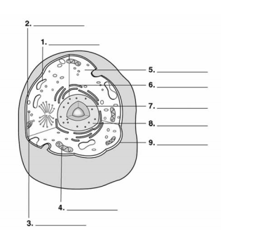
Label the Plant Cell:
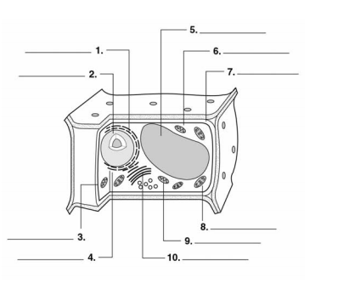

Label the Bacterial Cell:
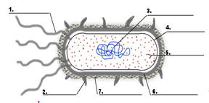

Label the Microscope Parts:
